Git Assignments

Section-0

1.create a directory project_dir and cd to project_dir

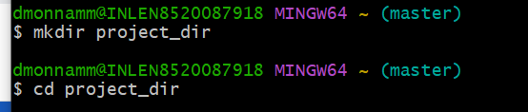

2.Initializing git version Database

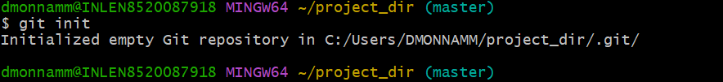

3.create a new file index.html

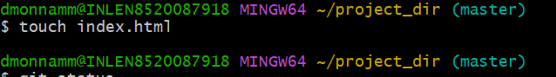

4.chack git status .you should find index.html as as untracked file

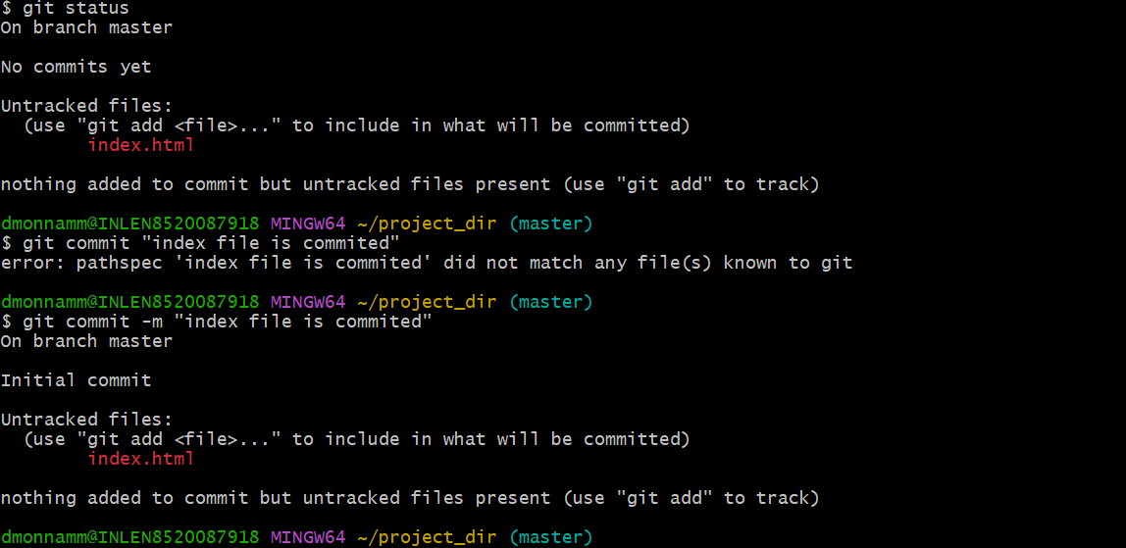

5.stage the index.html file

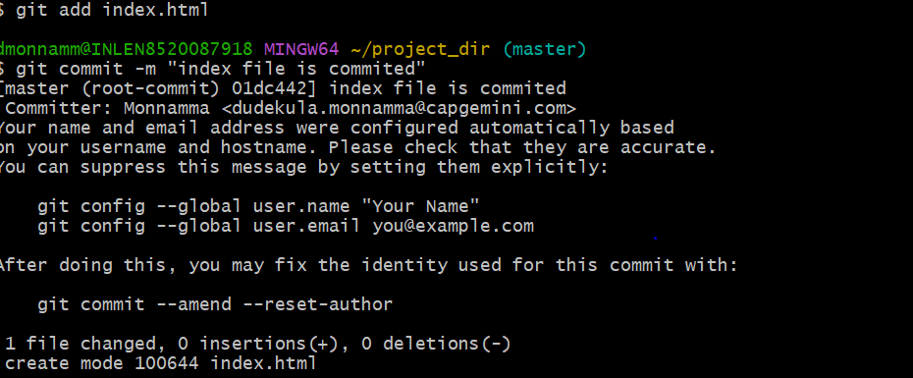

6.commit index.html

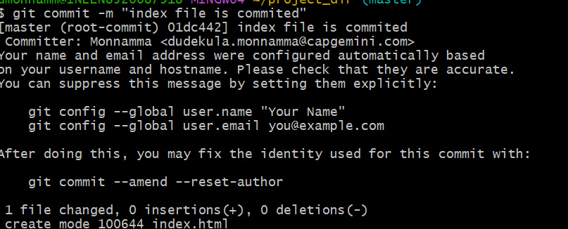

7.make few changes in index.html and create a new file info.txt file

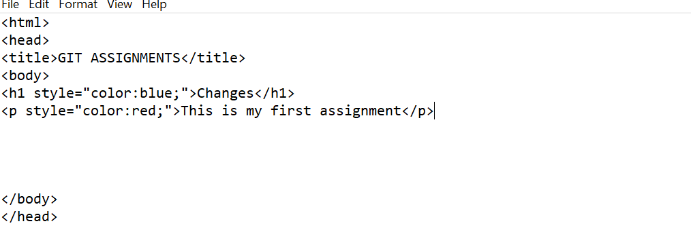

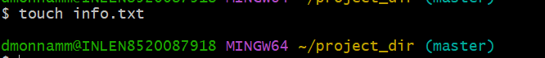

8.chech git status.you should find index.html and info.txt as untracked file

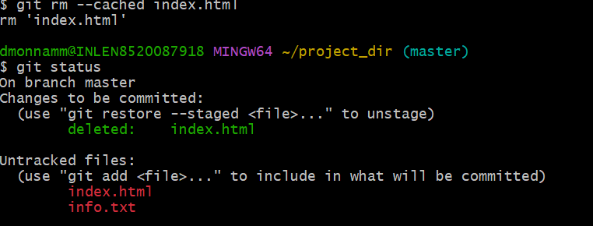

9.configure git to ignore all txt files

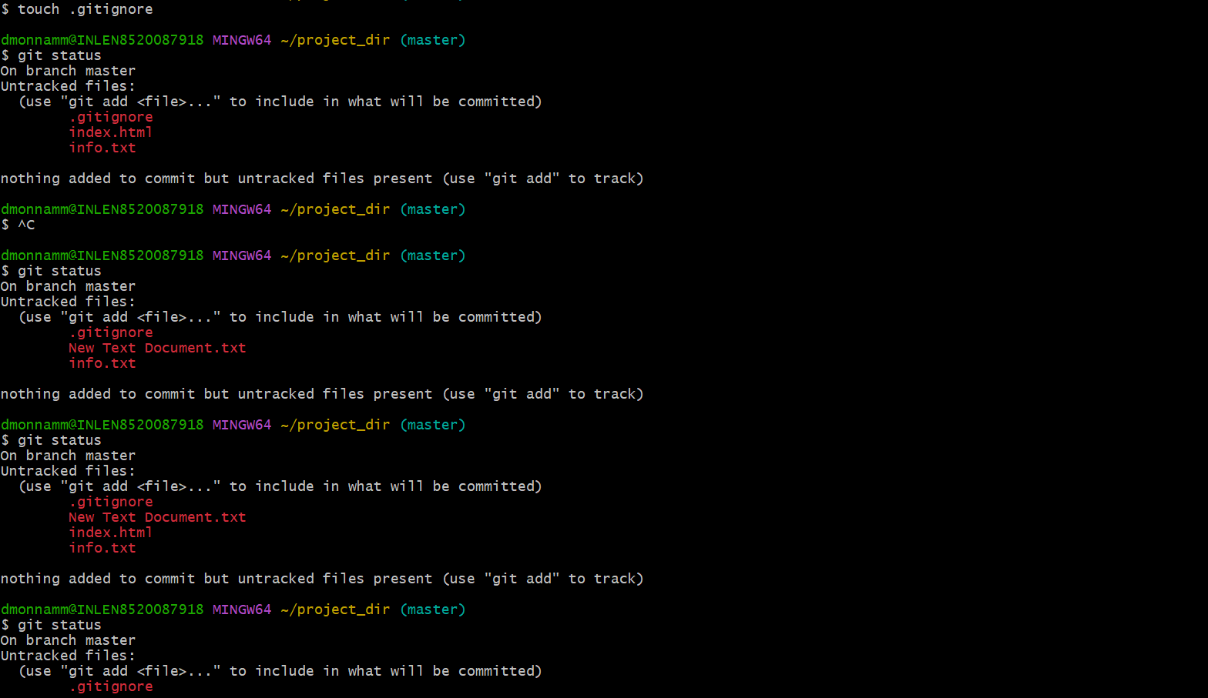

10.Again check git status.you should find only index.html as untracked file

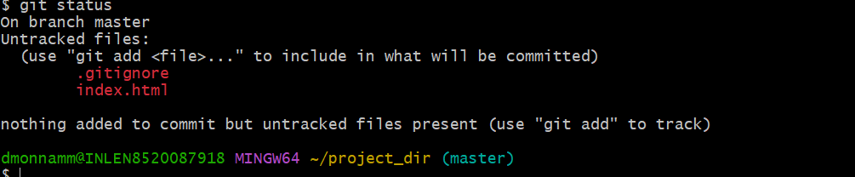

12.log all your commits so far

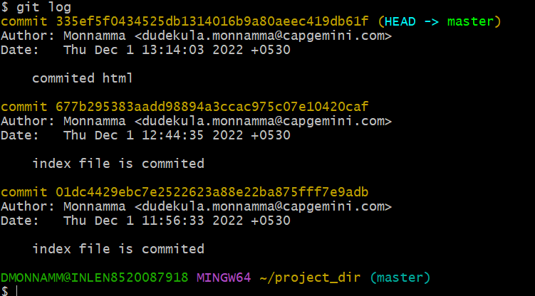

13.make some changes in index.html

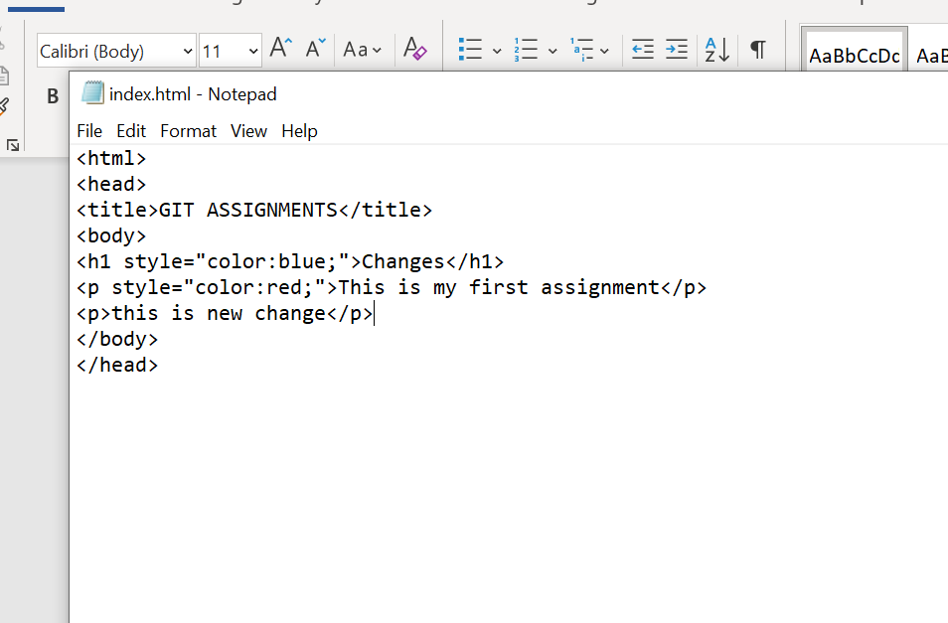

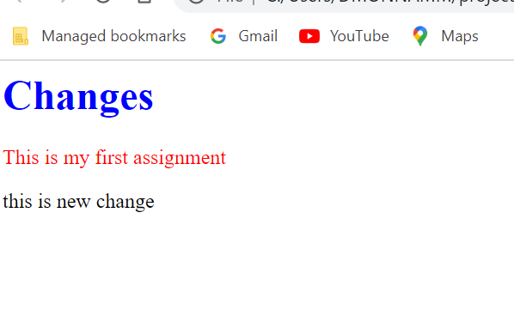

14.Revert the change made in the previous step using git command



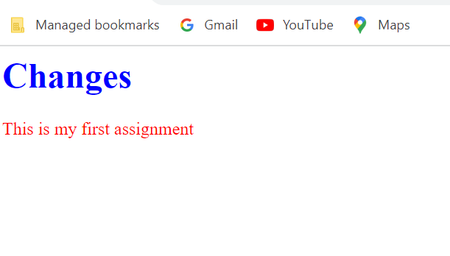

15.Again change index.html

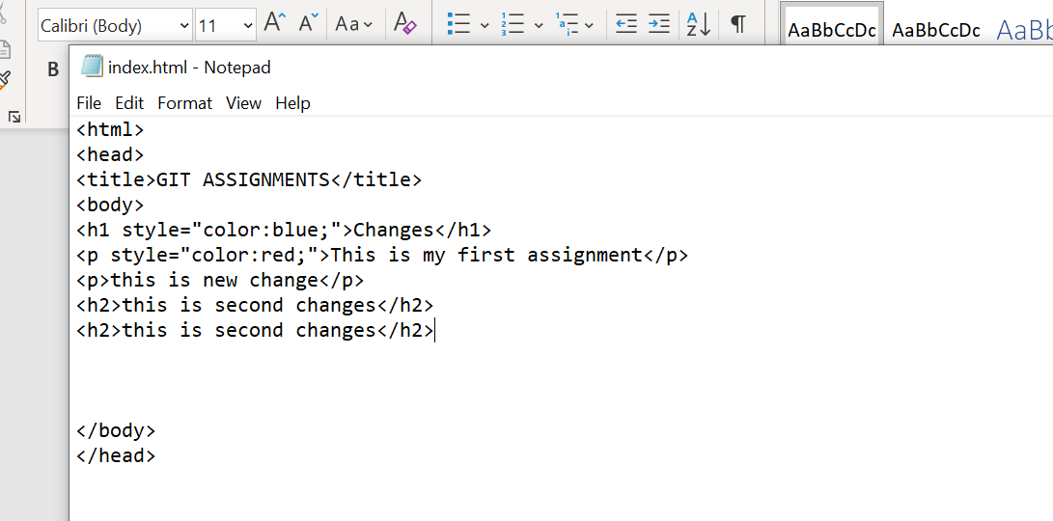

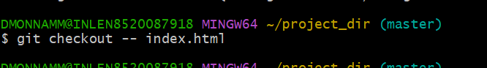

16.stage the index.html



17.Revert back the last stage

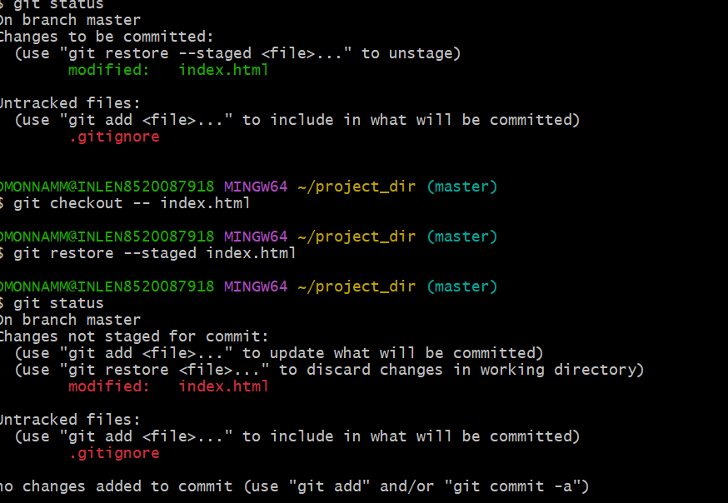

18.Rename add command to “my-add”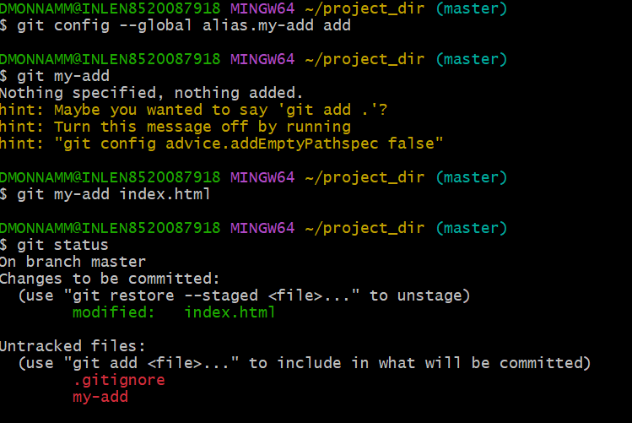

19.Using my-add stage index.html again and commit the changes

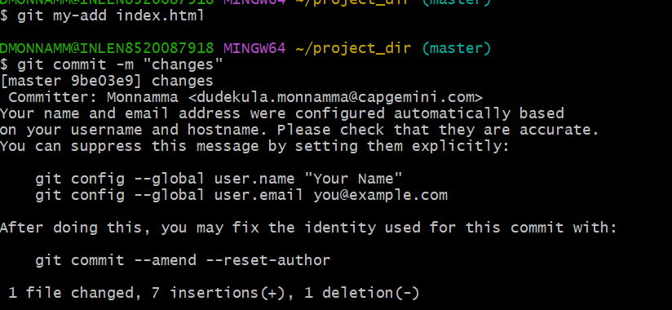

20.Revert the last commit

